Salute to a giant African academic

[**Patrick Bond**](https://mg.co.za/author/patrick-bond)**17 Aug 2018**

[[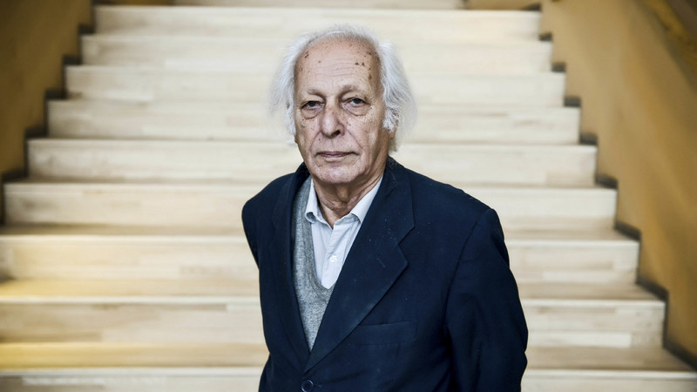](https://mg.co.za/article/2018-08-17-00-salute-to-a-giant-african-academic)](https://mg.co.za/article/2018-08-17-00-salute-to-a-giant-african-academic" \o ")

[Samir Amin was as ruthless a critic of extreme religious movements as of neoliberal imperialism. (Ricardo Ramirez)](https://mg.co.za/article/2018-08-17-00-salute-to-a-giant-african-academic" \o ")

### OBITUARY

Samir Amin (1931-2018)

Samir Amin’s celebrated life was perhaps among the most trying but also rewarding of his generation’s left intelligentsia. After his death in Paris on Sunday, a wider awareness of his extraordinary contribution to applied theory is rising.

Amin spent a privileged youth in Egypt as the child of two medics, and attended university in Paris where his PhD offered a scathing analysis of underdevelopment in low-income countries. He returned home, but having acquired a better understanding of the limits of Egypt’s then president Gamal Abdel Nasser’s nationalism (and as an anti-Stalinist communist), Amin was forced into exile in 1960. He soon won credibility for his tireless United Nations economic planning duties in West Africa, especially Mali.

By 1970, he was appointed director of the UN’s Institut Africain de Développement Economique et de Planification (IDEP), based in Dakar, Senegal. He also found time to catalyse both a powerful Dakar-based nongovernmental organisation called Endato drive development, as well as the Council for the Development of Social Science Research in Africa (the continent’s main academic society with more than 4000 members). Both are still going strong today.

Still, within a decade, his progressive strategies had alienated the well-known Nigerian who led the UN Economic Commission on Africa, Adebayo Adedeji, and so he moved from IDEP a few blocks away to start the Third World Forum, an institute he led until his death. The Forum on World Alternatives was one of the offshoots. Thanks to Amin’s networking, the forum can claim centrality within early social movement contributions to global justice organising, five years before the World Social Forum came into being.

I visited Amin in Dakar six months ago, where his old-fashioned home office in a dilapidated bank building continued to buzz with new essays and draft books. He was as sharp as ever, though with far less confidence in statist counter hegemonic prospects and with an amplified hope for new waves of grassroots activism.

Amin’s best-known books, among the most cited from Africa, came at the height of dependency theory’s popularity during the 1970s: Unequal Development; Accumulation on a World Scale; Eurocentrism; and Imperialism and Unequal Development.

His 1990 book, Delinking, summed up why the still-young era of globalisation would further underdevelop Africa, and why a more self-reliant strategy would be necessary.

Langa Zita, the director of political education and training for the ANC in Gauteng, wrote a master’s thesis drawing mainly upon this book. Says Zita: “Amin reread the liberation movements not only from the standpoint of their slogans but also as an expression of the class tendencies that animated such movements. His ideas live. We will continue to draw our sustenance from those ideas as they empower [us] in our efforts to chart a path to socialism.”

Amin’s memoir, A Life Looking Forward, was published in 2006 and contains delightful tales about his youth and professional score-settling of a political-intellectual nature (as opposed to personalistic or sectarian), as well as profound appreciations offered to Isabella, his wife of 60 years. More recent books include Ending the Crisis of Capitalism or Ending Capitalism? ; Global History: A View from the South; Capitalism in the Age of Globalization; and The Law of Worldwide Value. He was as ruthless a critic of extreme Islam and other religious movements as of neoliberal imperialism.

In one book, From Capitalism to Civilization (2010), he traced South Africa’s shameful historical role in world capitalism. On occasional visits to the country, Amin regularly expressed dissatisfaction with the post-liberation political economy. He believed that far too many concessions were made to capital, that Africa’s most capable industrial base was destroyed by excessive liberalisation, and that Pretoria was too willing to relegitimise Western power.

The main merit of Marxist analysis, Amin argued two years ago, is its “claim simultaneously to understand the world, our capitalist global world at each stage of its deployment, and provide the tools which make it possible for the working classes and the oppressed peoples, i.e. the victims of that system, to change it”.

Amin endorsed an epistemology not based on participatory action research but on conflict-seeking research: “Marxism does not separate theory from practice; Marxist praxis associates both. Marxists try to understand the world through the processes of action to change it. You do not understand first through a process of academic research developed in isolation and then eventually try to modify reality by making use of the theory. No. Marxist praxis is a process which involves simultaneously theory and practice, mobilising all ordinary people, the working classes and the oppressed nations. While you progress in your struggles, you understand better the reality that you are fighting against.”

### Amin on the effect of colonialism on SA’s political culture

This is an edited excerpt from Samir Amin’s book From Capitalism to Civilization: Reconstructing the Socialist Perspective (2010):

In South Africa, the first settler-colonisation —the one of the Boers —led to the creation of a “purely white” state involving expulsion or extermination of Africans. In contrast, the initial objective of the British conquest was to forcibly submit Africans to the requirements of the metropolis’ imperialist expansion primarily for the exploitation of the minerals.

Neither the first colonisers (the Boers) nor the new ones (the British) were capable of standing as autonomous centres. The apartheid state of the post-war period attempted to do so, basing its power on its internal colony —black for the essential part —but did not reach its ends owing to an unfavourable numerical balance and to the growing resistance of the dominated populations who will finally be victorious. The powers in place after the end of apartheid have inherited that issue of internal colonisation without having, up to now, brought in its radical solution.

The case of South Africa is especially interesting from the point of view of the effects of colonialism on political culture. It is not only that here, internal colonisation was bluntly visible, even to blind people. It is also because communists in that country had been able to draw from the situation a lucid analysis of actually existing capitalism.

The South African Communist Party (SACP) was, in the 1920s, the promoter of the theory of internal colonialism, a theory adopted in the 1930s by a black leader of the Communist Party of the United States —Harry Haywood —though it was not followed by his “white” comrades. He drew from that theory the consequences that high profits for the “white” minority and incredibly low wages for the “black” majority, constitute the front and back faces of the same issue.

South Africa is a microcosm of the global capitalist system. It gathers on its territory the three components of that system: a minority that benefits from the rent of situation of the imperialist centres, two majority components of more or less equal importance distributed into an industrialised “Third World” (the emerging nations of today), and a marginalised “Fourth World” (in the former Bantustans), similar to the non-industrialised regions of contemporary Africa.

What is more, the proportions between those three components’ populations are more or less the same as those that characterise the current global system.

That fact certainly contributed to giving South African communists the clairvoyance that was theirs. That political culture has died out today, not only in South Africa, with the (belated) adhesion of the SACP to the commonplace thesis of “racism” (which gives the status of a cause to what is a mere effect); but also at global level, with the adhesion of the majority of communists to social democracy.

https://mg.co.za/article/2018-08-17-00-salute-to-a-giant-african-academic